|  |  |
| --- | --- |
| \\VFILERDPI\DPI-Home\OBRIENR2\My Documents\Downloads\PP logo.jpg |  |
| **SUPPLEMENTARY PANEL ASSESSMENT BRIEFING REPORT**  HUNTER AND CENTRAL COAST REGIONAL PLANNING PANEL | |

|  |  |
| --- | --- |
| PANEL REFERENCE & DA NUMBER | PPSHCC-255 - PAN-377087 – DA/2036/2023 |
| PROPOSAL | Alterations and additions – Educational Establishment & Includes Demolition |
| ADDRESS | Lot 1 DP530125 458-468 Main Road, Noraville NSW 2263 |
| APPLICANT | Trustee of the Roman Catholic Church for the Diocese of Broken Bay C/- DFP Planning |
| OWNER | Trustee of the Roman Catholic Church for the Diocese of Broken Bay |
| DA LODGEMENT DATE | 6 November 2023 |
| APPLICATION TYPE | Integrated Development Application – Bushfire Prone Land – Special Fire Protection Purpose |
| REGIONALLY SIGNIFICANT CRITERIA | Clause 5, Schedule 6 of the SEPP Planning Systems: Private Infrastructure and community facilities over $5 Million |
| CIV | $9,286,000 (excluding GST) |
| CLAUSE 4.6 REQUESTS | N/A |
| LIST OF ALL RELEVANT PLANNING CONTROLS (S4.15(1)(A) OF EP&A ACT) | * *SEPP (Planning Systems) 2021* * *SEPP (Resilience and Hazards) 2021* * *SEPP (Biodiversity and Conservation) 2021* * *SEPP (Transport and Infrastructure) 2021* * *Central Coast Local Environmental Plan 2022* * Central Coast Development Control Plan 2022 |
| TOTAL & UNIQUE SUBMISSIONS | One – Objection - extent of written notification, length of notification period. |
| ORIGINAL DOCUMENTS SUBMITTED FOR CONSIDERATION | The Statement of Environmental Effects identifies the following reports and details submitted in support of the Development Application:   * Survey (prepared by Clarke Dowdle & Associates); * Arborist Report (prepared by Advanced Treescape Consulting); * Architectural Plans (prepared by Glendenning Szoboszlay Architects); * Architectural Design Statement (prepared by Glendenning Szoboszlay Architects); * Landscape Plans (prepared by iScape Landscape Architecture); * Acoustic Assessment (prepared by JHA); * Preliminary Site Investigation (prepared by EBG Environmental Geoscience); * Traffic Impact Assessment (prepared by Traffix); * Stormwater & Civil Plans (prepared by Jones Nicholson); * Accessibility & BCA Assessment (prepared by Accessed); * Geotechnical Assessment (prepared by Crozier Geotechnical Consultants); * Bushfire Assessment (prepared by Building Code & Bushfire Hazard Solutions); * Waste Management Plan (prepared by MRA Consulting Group); * Acid Sulfate Soils Assessment Report (prepared by EBG Environmental Geoscience); * Cost Estimate Report (prepared by Wilde and Woollard); * Ecology Report (prepared by AEP); * Flood Impact Assessment (prepared by Jones Nicholson); and * Plan of Management (prepared by St Mary’s Toukley Catholic Primary School). |
| SUPPLEMENTARY DOCUMENTS SUBMITTED FOR CONSIDERATION | Applicant’s Submission in reply to matters for deferral, 6 November 2024 prepared by Don Fox Planning.  Traffic and Access Operational Management Plan (TAOMP) has been prepared by Traffix, |
| PLAN VERSION | 8 March 2024 Version No. 05 (Multiple Versions) |
| PREPARED BY | N Burr |
| DATE OF REPORT | 18 January 2025 |

**BACKGROUND**

The Hunter and Central Coast Regional Plannng Panel (the Panel) considered a report and associated memo recommending consent be granted to development application 2036/2023 subject to conditions of consent at its meeting of 25 September 2024.

On 27 September 2024 the Panel resolved to defer the determination of the development. The record of deferral indicates that the Panel is generally satisfied the built form is appropriately located, and the site constraints are able to be adequatly addressed however, there are elements of the proposal that are not well articulated in the development application or assessment report. Accordingly, the following information was requested by the Panel:

1. *Details of all uses on site, including hours of operation and number of people/students/staff.*
2. *Details of existing drop-off/pick-up arrangements, including buses.*
3. *Details and clear definition of the car park to accommodate drop-off/pick-up, bus, vistior and staff parking, as well as pedestrian routes.*
4. *Changes to the car park layout required to support the development.*
5. *A Traffic and Access Operational Management Plan that addresses all the functional requirements of all uses and how drop-off/pick-up and car parking will be managed across the site.*
6. *An update of the Flood Emergency Response Plan to reflect the Traffic and Access Operation Management Plan and correct references to flood events.*
7. *Details of the type and height of fencing around the High Hazard Floodway.*

**CCONSIDERATION OF DEFERRED MATTERS**

1. *Details of all uses on site, including hours of operation and number of people/students/staff.*

The applicant has provided the following summary of operations on the site.

*Currently operating on the site is an existing primary school (St Mary’s Catholic Primary School, Toukley) and a place of public worship (Our Lady of Perpetual Succour Catholic Church).*

*The school is located within the northern and western portions of the site. The classrooms that are used by the school are located towards the west of the site, with a large oval located to the east of the school campus. At the completion of the development, the school will become ‘three-stream’, which enables each year group to provide for three (3) classes.*

*The school will be occupied by staff between 7am and 6pm, Monday to Friday. Between 7am and 8:55am, the staff arrive at the site and prepare for the school day. Students typically begin to arrive at the school from 8:15am-8:30am, with the official bell time for starting the school day being at 9am. The school day runs from 9am to 3:15pm. Between 3:15pm and 6pm, some of the school buildings are utilised by staff for Professional Development, curriculum preparation time and occasional staff meetings. The Parish Hall and school grounds are also utilised for Out of School Hours (OOSH) activities. The Plan of Management* [included as an [Attachment] *has been updated to reflect the aforementioned hours of operation.*

*Also located within the school campus is an ‘Aspect’ class, which provides specialised education for children on the autism spectrum. The maximum capacity of this class is 20 students, with 15 students currently enrolled.*

*The maximum student capacity of St Mary’s Catholic Primary School, Toukley will be 630 students and 54 staff employed on a variety of full-time and part-time levels. Currently, an average of 40 staff are on site on any given day, with the proposal forecast to increase this to 44 staff per day (which includes Aspect Staff).*

*Located in the south eastern corner of the site is Our Lady of Perpetual Succour Catholic Church, which includes the main Church building with a capacity of approximately 500 seats and separate spaces for use by employees / pastors of the Church.*

*Mass commences at 9am Mondays to Thursdays and 9:30am on Fridays and lasts for a duration of 30-45 minutes. Typically, in the order of 30 people attend weekday morning Mass.*

*Occasional funerals are held on weekdays with the earliest start time typically being 10am so as to not conflict with morning mass and finishing by 2:30pm. Typical attendance is between 75 to 100 persons. It is noted that the timing of funerals do not coincide with pick up and drop off times of the primary school.*

*A Parish Hall is located on site which is a shared use between the school and the Church. During the week the Parish Hall is utilised by the school for various uses, occasional assemblies and OOSH activities. On the weekends, when the school is not operational, the Parish Hall is utilised by the Church.*

1. *Details of existing drop-off/pick-up arrangements, including buses.*
2. *Details and clear definition of the car park to accommodate drop-off/pick-up, bus, vistior and staff parking, as well as pedestrian routes.*
3. *Changes to the car park layout required to support the development.*

The applicant has addressed deferred items (ii), (iii) and (iv) as a singular topic related to the operation of the car park and any works required. The following is an extract of the applicant’s submission addressing the above deferred matters.

*A* *Traffic and Access Operational Management Plan (TAOMP) has been prepared by Traffix, dated 6 November 2024* [Attached to this report] *which details how drop-off and pick-up (DOPU) arrangements will be managed. This includes measures, including minor upgrades to the existing car park, to facilitate a clearer and improved DOPU arrangements.*

***Figure 1*** *is an extract of the proposed Signage and Line Marking Plan that will provide for improved pedestrian circulation, as well as management of vehicles that enter and exit the site.*

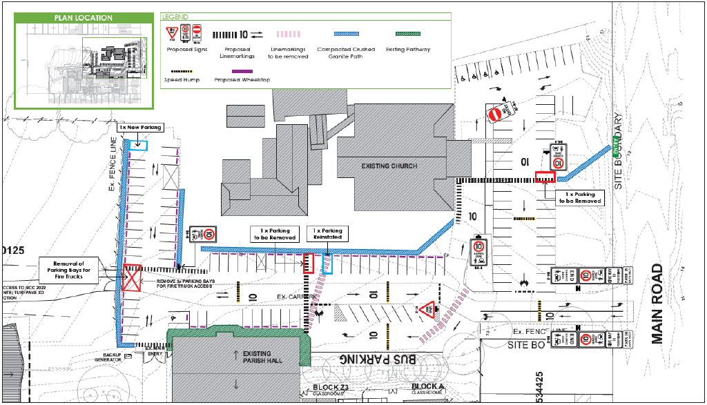

*Figure 1 Line marking and Signage Plan. Source: Traffix*

***Figure 2*** *is an extract of the proposed car parking allocation for DOPU, staff and morning Mass (130 spaces total).*

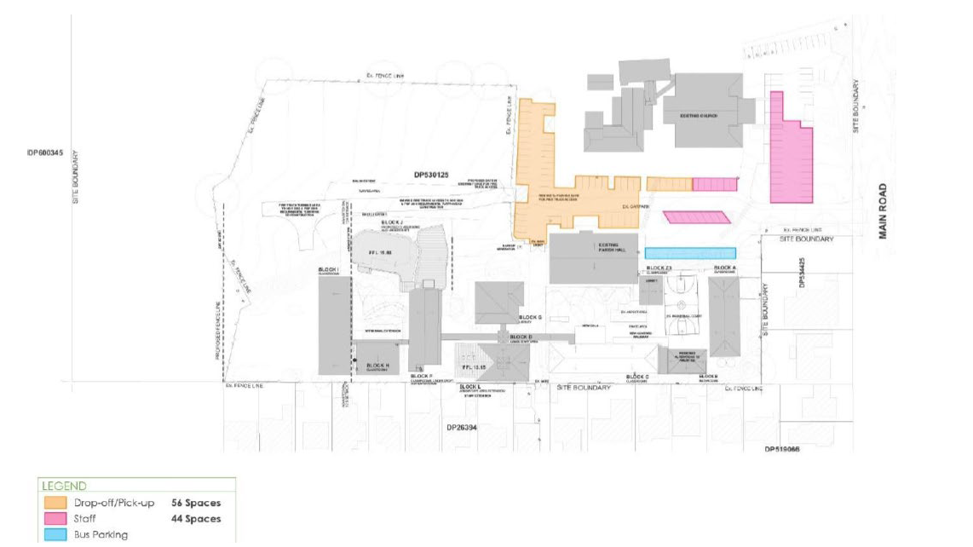

*Figure 2 Car Parking Allocation Plan. Source: Traffix*

*The proposed arrangements provide for 56 DOPU spaces in the northern portion of the car park near the school entry (north of the Parish Hall). An existing pathway is also provided, which links to a secondary pedestrian access to the south of the Parish Hall and adjacent to the bus bay. To facilitate a separated pedestrian path of travel from vehicles, compacted crushed granite paths are proposed adjacent to the car parking spaces, which connect to modified pedestrian crossings throughout the car park.*

*The existing bus bay will be retained on the western side of the car park. The bus bay is capable of accommodating two (2) buses. The location of the DOPU spaces are to the north of the bus bay. Therefore, parents and children walking to the main school gate from the DOPU spaces are separated from buses that enter and exit the site.*

*Staff parking for 44 vehicles is proposed within the central portion of the car park, with the remaining 30 spaces to be available for use by the Church in the southern portion.*

*On weekdays, when occasional funerals are held, the DOPU parking spaces can be made available, which enables 86 spaces to service the typical funeral attendance of 75-100 people.*

The Traffic and Access Operational Management Plan (TAOMP) identifies the various uses occurring on the site including the school, church including funeral services, and out of school hours care. There is likely to be some overlap of various land uses in terms of the times in which they operate however, the peak demands for each use do not coincide. The TAOMP establishes the following parking allocations within the site in respect to the respect user groups who place demand on the parking.

* *44 x staff spaces;*
* *56 x student drop-off/pick-up (DOPU) spaces; and*
* *30 x visitor/church spaces.*
* *2 x bus spaces*

The TAOMP recommends the following works be carried out to improve the safety and efficiency of the car park and access including the following (as depicted in figure 1 from the applicant’s submission above)

* *Removal of existing crossing pedestrian line markings;*
* *Additional directional arrows and line marking for improved vehicle circulation;*
* *Additional off-road pedestrian paths (compacted crushed granite);*
* *Additional pedestrian line marking to improve safety;*
* *Additional traffic signage to supplement line marking; and*
* *Additional 10km/h shared zone signage to supplement existing signage.*

The use of compacted gravel pathways is considered satisfactory by Council’s Development Engineer for the type of access and proposed user.

The TAOMP further articulates the existing parking and access arrangements and proposes improvements in the way of line marking and pedestrian facilities. The further information does not fundamentally alter the findings of the original assessment with regard to the development being considered to be acceptable in terms of parking and access.

1. *A Traffic and Access Operational Management Plan that addresses all the functional requirements of all uses and how drop-off/pick-up and car parking will be managed across the site.*

The applicant’s submission (included below) cites to the TAOMP referred to in the discussion pertaining to items (ii), (iii) and (iv) above.

*A TAOMP has been prepared by Traffix that has addressed the requirements of the uses on site and documents how drop-off and pick-up will be managed across the site.*

The submitted TAOMP is considered to satisfy the deferred matter and has been incorporated into the recommended conditions of consent.

1. *An update of the Flood Emergency Response Plan to reflect the Traffic and Access Operation Management Plan and correct references to flood events.*

The Applicant’s submission in response to the deferred matter is included below.

*The Traffic and Access Operational Management Plan does not give rise to any changes to the Flood Emergency Response Plan (FERP)* [Attached to this report]. *Therefore, the latest version of the FERP, dated 6 June 2024, remains relevant to the proposed development.*

The Traffic and Access Operational Management Planhas been prepared cognisant of the FERP. There are no particular changes to the FERP and the shelter in place or emergency access location in the FERP triggered by the Traffic and Access Operational Management Plan and amendments to the FERP are not required. The recommended conditions of consent require the implementation of the FERP in association with the development.

1. *Details of the type and height of fencing around the High Hazard Floodway.*

The proposed development does not include any changes to the existing perimeter fencing which is considered commensurate with the school use and of sufficient design and construction to not warrant additional works. The applicant’s submission with respect to this matter of deferral is below and includes photographs of the subject fencing for reference.

*The fencing located around the site is mostly palisade fencing to a height of 2.1m. This includes fencing that abuts the bus bay and the main school entry, as well as the fencing that fronts Main Road and along the south eastern side of the site. The fencing around the school oval is a 2.0m high palisade fence.*

*Photograph’s of the fencing that is located around the school site are provided at Figure 3 to Figure 6 below.*

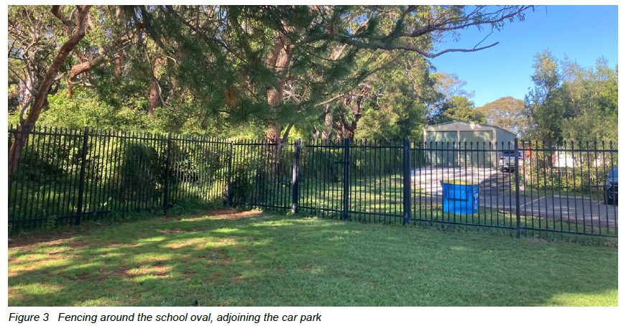

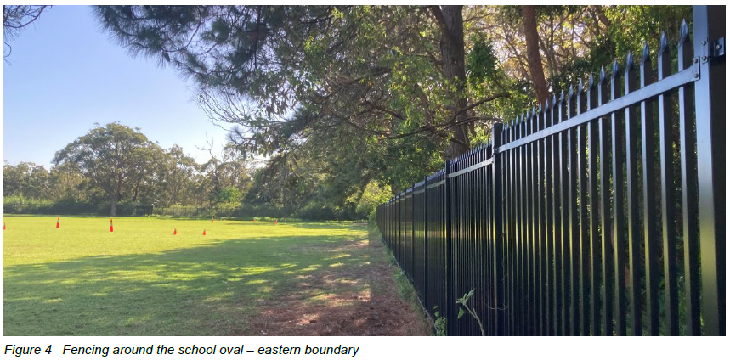

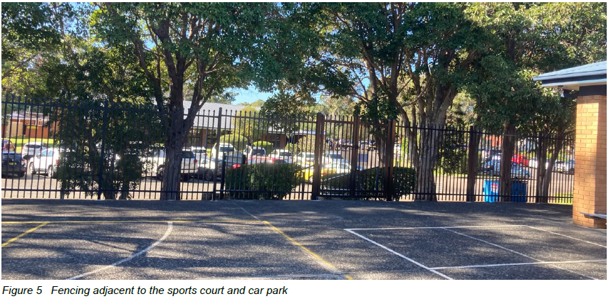

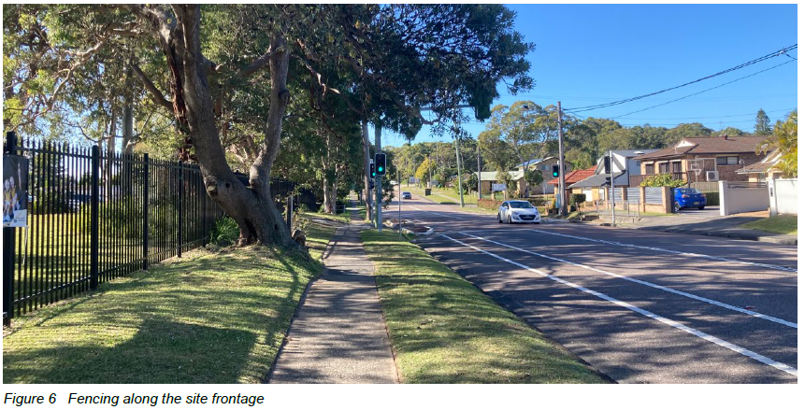

**CONCLUSION**

The application has been considered in accordance with the requirements of the EP&A Act and the Regulations, as outlined in this supplementary report, the original assessment report and associated memo dated 25 September 2024. The following is a summary of prerequisite conditions for the granting of development consent that have been considered in the assessment report and provided as part of the conclusion, for the benefit of the Panel:

* The Panel can be satisfied that the relevant General Terms of Approval have been obtained from the NSW Rural Fire Service in accordance with section 4.47(2) of the *Environmental Planning and Assessment Act, 1979*, and that the recommended conditions of consent are consistent with the General Terms of Approval in accordance with section 4.47(3) of the *Environmental Planning and Assessment Act, 1979*.
* In accordance with Chapter 4, section 4.9(2) of the *State Environmental Planning Policy (Biodiversity and Conservation) 2021,* the Panel can be satisfied that the development will have no impacts upon koalas or koala habitat.
* Having regard for Sections 2.8, 2.11 and 2.12 of *State Environmental Planning Policy (Resilience & Hazards) 2021*, the Panel can be satisfied that the proposed development is designed, sited, and will be managed to avoid an adverse impact referred to in s.2.8(1) and s.2.11(1), and the development is not likely to cause increased risk of hazards on the subject site or other land.
* The Panel can be satisfied that the land is suitable for the proposed development and does not include land referenced in section 4.6(4) of the *State Environmental Planning Policy (Resilience and Hazards) 2021* nor does it involve a change of use of the land. Accordingly, the development is satisfactory having regard for the provisions of section 4.6 of the same SEPP.
* Having regard for the prerequisite conditions to the granting of consent under the *Central Coast Local Environmental Plan 2022,* the Panel can be satisfied that:
  + Clause 5.21 – Flood Planning

The proposed development:

1. Is compatible with the flood function and behaviour on the land, and
2. Will not adversely affect flood behaviour in a way that results in detrimental increases in the potential flood affectation of other development or properties, and
3. Will not adversely affect the safe occupation and efficient evacuation of people or exceed the capacity of existing evacuation routes for the surrounding area in the event of a flood, and
4. Incorporates appropriate measures to manage risk to life in the event of a flood and
5. Will not adversely affect the environment or cause avoidable erosion, siltation, destruction of riparian vegetation or a reduction in the stability of riverbanks or watercourses.
   * Clause 5.22 – Special Flood Considerations

The proposed development:

(a) will not affect the safe occupation and efficient evacuation of people in the event of a flood, and

(b) does incorporate appropriate measures to manage risk to life in the event of a flood, and

(c) will not adversely affect the environment in the event of a flood.

* + Clause 7.6 – Essential services

All services essential for the proposed development remain available to the subject site.

**RECOMMENDATION**

That Development Application No. DA/2036/2023 for the alterations and additions to the existing educational establishment, being St Mary’s Catholic Primary School, at 458-468 Main Road, Norraville NSW, be APPROVED pursuant to Section 4.16(1)(a) of the *Environmental Planning and Assessment Act 1979* subject to the draft conditions attached to this report at Attachment A.

The following attachments are provided:

* Attachment A – Draft Conditions of Consent
* Attachment B – Applicant’s submission addressing matters for deferral.
* Attachment C – Traffic and Access Operational Management Plan
* Attachment D – Flood Emergency Response Plan
* Attachment E – Record of Deferral